|  |  |  |
| --- | --- | --- |
| Artificial intelligence | HTML PROJECT | |
| **NAME / Menna Sobhy Mohamed Ellithy GROUP / 8 SEC / 43 B.N / 16** | |  |

Artificial intelligence (AI) is intelligence demonstrated by machines, unlike the natural intelligence displayed by humans and animals, which involves consciousness and emotionality

In my website I will discuss some important points about ARTIFICIAL INTELLIGENCE like:

* Applications of Artificial intelligence
* Areas of Applications of Artificial intelligence
* History of Artificial intelligence
* The meaning of Artificial intelligence

So this is some **SCREENSHOTS** of my website:

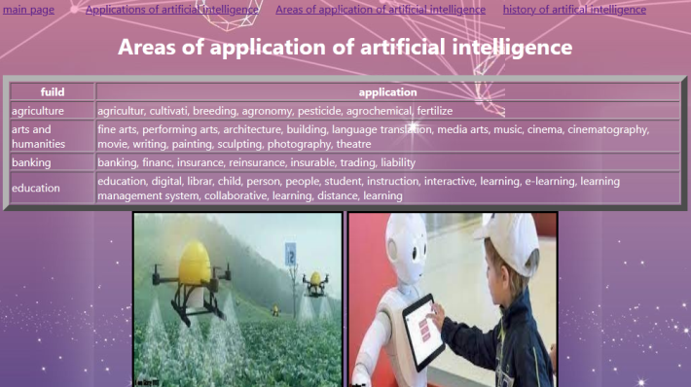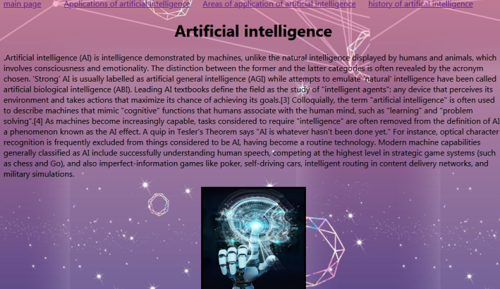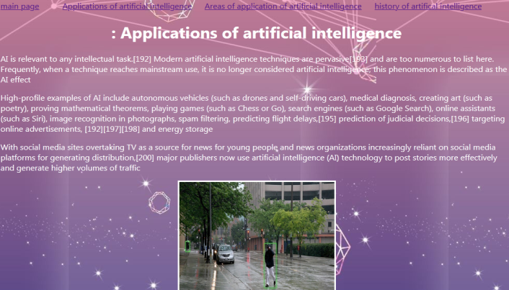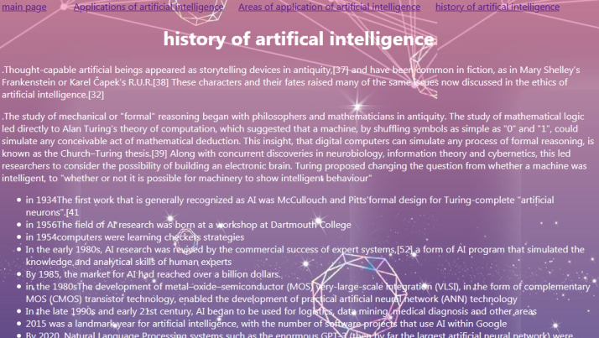

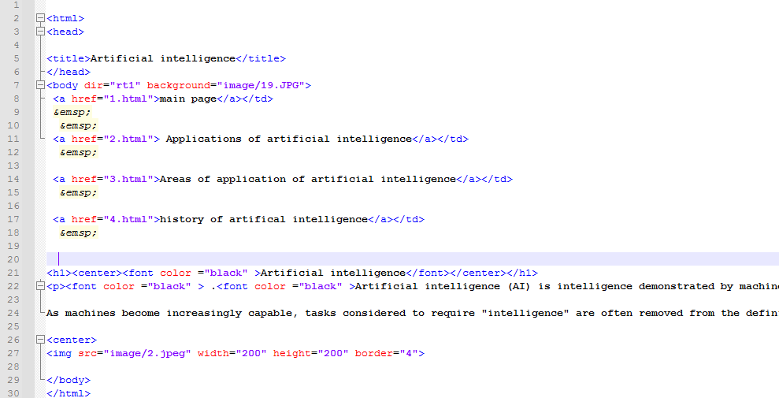And some **Screenshots of HTML codes** :

